OCEANA COUNTY 4-H MARKET LIVESTOCK

EDUCATIONAL NOTEBOOK/RECORD

##### STEER PROJECT - 2023

AGES 15 - 19

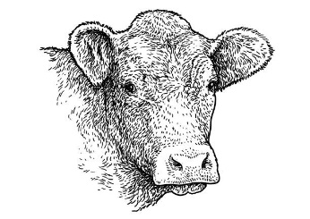

As a member of the 4-H Market Livestock Steer Project, you are required to submit your records as part of an educational project notebook in order to sell your animal at the 4-H Market Livestock Sale. **This notebook must be shown to the Oceana County 4-H Market Livestock Committee's Weighmaster at the time of weigh-in and then entered by you in the Educational Notebook Division of the Oceana County Fair on Entry day.**

**AGE:** _______

The age you enter depends on how old you are or will be on January 1, 2023

**Number of years in project:** ________

Use this sheet as the first page of your project record book. Fill it out completely.

**Please print neatly.**

NAME __________________________________________________________________

4-H CLUB _______________________________________________________________

BREED _________­­­­­­­­__________________________­­­­­­­­­­­­­__­­­­­­­­­­­­­­­­­­­­­­­­­­­­­­­­­____________________________­­­­­­­­­

STEER’S NAME _________________________________________________________

LOCATION WHERE ANIMAL IS RAISED ______________________________________



## **JUDGE’S SCORE/COMMENT SHEET**

## **(PLEASE DO NOT REMOVE, PLACE THIS SHEET IN SHEET PROTECTOR OR GLUE TO COVER). This sheet must be kept free for the judge to write their comments.**

## This sheet should help each 4-H’er understand their ribbon placing.

## A. **Specific educational value or worth**

## ___ All questions were answered completely

## ___ All calculations were correct

## ___ Calculations were incorrect

## ___ Questions were not answered (missed questions)

## B. **Notebook contains all project records**

## ___ Notebook contained all project records and were fully completed

## ___ Notebook contained additional project related information (research

## materials etc.)

## ___ Project records were incomplete

## ___There was no additional project related information

## C. **Accuracy, neatness and general appearance**

## ___Notebook was neat in appearance (typed/hand printed)

## ___Notebook pages were clean and stain free

___Notebook pages were in order and complete

___Notebook was difficult to read and messy

__Notebook had wrinkled and stained pages

Other Comments: _______________________________________________________

______________________________________________________________________

______________________________________________________________________

## **4-H MARKET LIVESTOCK STEER NOTEBOOK**

**AGES 15-19**

**TABLE OF CONTENTS**

*Please keep your notebook in Table of Contents order.*

1. GENERAL GUIDELINE INFORMATION
2. JOURNAL OF CARE
3. PROJECT INFORMATION
4. SPECIFIC PROJECT KNOWLEDGE
   1. Breed Scramble
   2. Marketing
   3. Marketing True & False
   4. Steer Parts Identification
   5. Halter Breaking Your Animal
   6. Retail Cuts
   7. Wholesale Cuts
5. YOUR PROJECT INFORMATION

a) Project Progress & Management Report

b) 4-H Knowledge

1. BUYERS NAMES
2. PICTURES OF YOUR PROJECT (1 page)
3. CLUB/NON CLUB POINT SHEET

APPENDIXES (OPTIONAL):

1. PICTURES OF YOUR PROJECT (additional pictures)
2. FEED INFORMATION (example: feed labels etc.)
3. ADDITIONAL INFORMATION ABOUT YOUR PROJECT
   1. Information you found in reference materials
   2. Information you located off the internet
   3. Information gathered from your feed representative
   4. Any other information

***\* Include notes as to why you researched this information and found it valuable, link it to your project if possible.***

Note: Reference materials used for the specific project knowledge include:

a. Extension publication 4-H 1188 – Your 4-H Market Beef Project

b. 4-H Market Livestock Beef Project Rules

c. Kansas State 4-H Online

d. The Ohio State University Learning Lab Online Site

2023- STEER RECORD BOOK (15-19) PAGE 1

This record book is part of your 4-H Market Steer Project. By keeping records up-to-date you will be able to see how much progress you make as you set goals and work to accomplish them. Write neatly and clearly. Feel free to add extra pages.

**PROJECT PICTURES**

Pictures are a required part of this notebook. Taking pictures of your project animal throughout the project will indicate how your animal has grown and developed. Add pictures to your notebook on a separate piece of paper.

**SCORING CRITERIA**

The following breakdown will be used during the judging process of all market livestock notebooks.

A. Specific educational value or worth **30%**

B. Creative way of showing what has been learned **10%**

C. Notebook contains all project records **50%**

D. Accuracy, neatness and general appearance **10%**

The Oceana County 4-H Market Livestock Committee encourages 4-H Leader and parent assistance with your project and project notebook. If you should have any questions, please contact the MSU Extension Office.

I, ____________________________ assisted ________________________ in

Parent/Leader/Adult Name 4-Her’s Name

understanding the questions and writing the answers. All answers are those of the 4-Her.

____________________________________

Signature of person helping with notebook

***If*** written help was needed

2023- Steer Record Book (15-19) Page 2

**JOURNAL OF CARE**

The 4-H Market Livestock Committee is **requiring all**4-H Market Livestock members to complete the “Journal of Care” so the judge may see the time, effort and care you have put into learning about your animal.

**\*\*** *Include things such as walked, fed,* *washed, clipped, trimmed, foot care, health practices, medicines, general maintenance (cleaning living & feed area),halter broke, training, had vaccinated, etc.* ***\*\****

DECEMBER - FEBRUARY

MARCH - MAY

2023- Steer Record Book (15-19) Page 3

**JOURNAL OF CARE** (continued)

JUNE - AUGUST

I, _______________________________, do attest and certify that this 4-Her has cared for

(property owner name-please print-if parent put parent’s name)

animal in a responsible manner while housed on my property. I also understand that integrity & responsibility are important to this 4-H experience.

____________________________________ ________ _________________

Signature of Property Owner or Parent Date

If housed on own property.

2023- STEER RECORD BOOK (15-19) Page 4

**PROJECT INFORMATION**

The start of the project will be the date the exhibitor placed the animal on feed. The end of the project will be weigh-in at fair.

Project Start Date: December 1, 2022 Project End Date: ______________

Fair Haul In Day

What month was your steer born? __________________

Please fill in the following information about your steer.

|  |  |  |  |  |  |  |  |
| --- | --- | --- | --- | --- | --- | --- | --- |
| Steer’s Name | Steer’s RFID Number | Breed | Date of Purchase | Price or Value | Starting Weight | Ending/Final Weight  **(FW)** | Total Pounds Gained |
|  |  |  |  |  |  |  |  |

**Note: Ending Weight-Starting Weight= Total Pounds Gained**

**MONTHLY FEED RECORD & EXPENSES**

|  |  |  |  |  |
| --- | --- | --- | --- | --- |
| Month | Type of feed used-  *(grain, silage, hay,*  *pasture, etc.)* | Supplements  *(if any used)* | Amount  *(indicate lbs.,*  *bales, etc.)* | Cost or Value of feed used for the month |
| December |  |  |  |  |
|  |  |  |  |  |
|  |  |  |  |  |
|  |  |  |  |  |
|  |  |  |  |  |
|  |  |  |  |  |
| January |  |  |  |  |
|  |  |  |  |  |
|  |  |  |  |  |
|  |  |  |  |  |
|  |  |  |  |  |
|  |  |  |  |  |

2023- STEER RECORD BOOK (15-19) Page 5

**MONTHLY FEED RECORD & EXPENSES (cont.)**

|  |  |  |  |
| --- | --- | --- | --- |
| Month | Type of feed used-  *(grain, silage, hay,*  *pasture, and/or Supplements etc.)* | Amount  *(indicate lbs.,*  *bales, etc.)* | Cost or Value of feed used for the month |
| February |  |  |  |
|  |  |  |  |
|  |  |  |  |
|  |  |  |  |
|  |  |  |  |
|  |  |  |  |
| March |  |  |  |
|  |  |  |  |
|  |  |  |  |
|  |  |  |  |
|  |  |  |  |
|  |  |  |  |
| April |  |  |  |
|  |  |  |  |
|  |  |  |  |
|  |  |  |  |
|  |  |  |  |
|  |  |  |  |
| May |  |  |  |
|  |  |  |  |
|  |  |  |  |
|  |  |  |  |
|  |  |  |  |
|  |  |  |  |

2023- STEER RECORD BOOK (15-19) Page 6 **MONTHLY FEED RECORD & EXPENSES (cont.)**

|  |  |  |  |
| --- | --- | --- | --- |
| Month | Type of feed used-  *(grain, silage, hay,*  *pasture, and/or Supplements etc.)* | Amount  *(indicate lbs.,*  *bales, etc.)* | Cost or Value of feed used for the month |
| June |  |  |  |
|  |  |  |  |
|  |  |  |  |
|  |  |  |  |
|  |  |  |  |
|  |  |  |  |
| July |  |  |  |
|  |  |  |  |
|  |  |  |  |
|  |  |  |  |
|  |  |  |  |
|  |  |  |  |
| August |  |  |  |
|  |  |  |  |
|  |  |  |  |
|  |  |  |  |
|  |  |  |  |
|  |  |  |  |
| Column Totals |  |  |  |

**Total Feed Costs for Project $ _______________**

2023- STEER RECORD BOOK (15-19) Page 7

**EXPENSES OTHER THAN FEED**

The 4-H Market Livestock Committee would like you to keep a running list of all of your expenses -- veterinary charges, bedding, insecticides, trucking, insurance, interest paid on money borrowed, housing etc. *EVEN IF HOUSED ON YOUR FARM THERE IS A COST TO HOUSE THEM FOR ELECTRICITY, BEDDING, ETC. PAID BY SOMEONE, it needs Included.*

|  |  |  |  |  |  |  |  |  |  |  |  |
| --- | --- | --- | --- | --- | --- | --- | --- | --- | --- | --- | --- |
|  | **Vet**  **Charges** | **Bedding** | **Insecticides** | **Equipment/Fitting & Showing Supplies** | **Trucking** | **Housing/ Rent** | **Shearing or Clipping** | **Advertising/**  **Marketing** | **Miscellaneous (specify)** | **Buyers Recognition** | **MONTHLY TOTAL** |
| **SEPT** |  |  |  |  |  |  |  |  |  |  |  |
| **OCT** |  |  |  |  |  |  |  |  |  |  |  |
| **NOV** |  |  |  |  |  |  |  |  |  |  |  |
| **DEC** |  |  |  |  |  |  |  |  |  |  |  |
| **JAN** |  |  |  |  |  |  |  |  |  |  |  |
| **FEB** |  |  |  |  |  |  |  |  |  |  |  |
| **MAR** |  |  |  |  |  |  |  |  |  |  |  |
| **APR** |  |  |  |  |  |  |  |  |  |  |  |
| **MAY** |  |  |  |  |  |  |  |  |  |  |  |
| **JUNE** |  |  |  |  |  |  |  |  |  |  |  |
| **JULY** |  |  |  |  |  |  |  |  |  |  |  |
| **AUG** |  |  |  |  |  |  |  |  |  |  |  |
| **TOTALS** |  |  |  |  |  |  |  |  |  |  |  |

2023- STEER RECORD BOOK (15-19) Page 8

**PROJECT EFFICIENCY INFORMATION**

#### Value of Animal at Time of Purchase **= ___________**

**__________________ ÷ _______________ = ____________________________**

Total lbs. of Gain Days on Feed Average Daily Rate of Gain

(from page 4)

**_______________ ÷ ___________________ = ___________________________**

Total Feed Cost Total lbs. of Gain Feed Cost per Lbs. of Gain

**_____________________ ÷ __________________ = __________________________**

Total lbs. of feed fed Total lbs. of gain Lbs. of Feed fed per lbs. of Gain

**________________ + _____________ + ______________ = _______________ (TE)**

Total Feed Expense Cost of Animal Other Expenses Total Project Expense

Beef animals are sold by the pound at a Large Animal Sale Auction. Find out what bid price (per lb.) you need to get at the Large Market Auction to **break even (BE)** on your market Beef Project.

**_______________ ÷ _________________ = __________________________________**

Total Expenses **(TE)** Final Weight **(FW)** Break Even Price **(BE)**

(or total cost per pound to raise your animal)

What is the current selling price of beef (per lb.)? ___________________________

Where did you find the current selling price? ___________________________________ (if your source was a person, ask them where they got this information)

Would you have been able to make a profit selling on the open market? ______________

Why or why not? _________________________________________________________

_______________________________________________________________________

_______________________________________________________________________

_______________________________________________________________________

2023- STEER RECORD BOOK (15-19) Page 9

**MARKETING**

One of the most important parts of any market animal project is marketing. This includes writing letter, talking to buyers and making sure that you thank previous buyers in a timely fashion.

* What did you do to market your animal this year?
* If you have participated in a market livestock project before, what did you do differently this year?

_______________________________________________________________________

_______________________________________________________________________

_______________________________________________________________________

_______________________________________________________________________

**MARKETING TIPS & TRICKS**

Answer True or False to the statements below on good marketing practices to use when attracting potential buyers.

It is best to seek potential buyers the week before the auction. T F

You should be polite and mindful of potential buyer’s time when

asking them to be a potential buyer. T F

Providing information on the breed of your animal to potential

buyers can be helpful. T F

Arriving at the potential buyer’s place of business at the busiest

time of the day is a perfect time to ask them to be potential buyer. T F

Sending an introduction letter or note to potential buyers is a good

way to make the first contact with potential buyers. T F

Being timely in following up with a thank you to the buyer is not

necessary. They will see the ad in the newspaper T F

Noticing the buyer’s that purchased the previous year and the

animals they purchased can help in determining who to contact. T F

You should stay in touch with potential buyers throughout the

duration of your project. T F

It is best to have your parents approach potential buyers on your

behalf, they are the adults. T F

2023- STEER RECORD BOOK (15-19) Page 10

**MARKETING TIPS & TRICKS (cont.)**

Thanking a buyer for just coming to the auction is not necessary T F

A handwritten thank you note on a scrap piece of paper is an

excellent way to thank your buyer. T F

Thanking the buyer with a small appreciation gift is a good

Idea. T F

Visiting buyers who previously purchased your animals is not

worth your time each year. T F

Presenting yourself in a business manner when approaching

a buyer to be a potential buyer is a good idea. T F

**BREED SCRAMBLE** –

Unscramble the following popular beef breeds next to the correct description.

___________________________ Large framed, red and white in color from

N A E I M - U O A N J France. This is the largest French breed of

cattle.

______________________________ White faced, known for their mothering &

D E F R O E H R foraging ability plus their docile disposition. The 2nd most numerous breed in the US.

______________________________ Large frame, solid white breed from France.

H L O R A A S C I They are known for their fast growth rates.

______________________________ Solid black polled breed. They are the most

S N G A U numerous cattle in the US and are noted for

Quality carcasses.

_______________________________ White faced, red or yellow breed. They are

L T I M S M A N E noted for good milk production. American

Versions are black or red with a blazed face.

_______________________________ Originally called Durhams, this British breed can

R H T H O O N S R be red, white or roan in color. They are noted

for their good disposition, mothering and milk production.

2023- STEER RECORD BOOK (15-19) Page 11

**BREED SCRAMBLE (cont.)**

Unscramble the following popular beef breeds next to the correct description.

__________________________ This breed of cattle are easy calving, good

N A E M R I A C A D R E E N B E natured cattle that are very feed efficient and

Maintain themselves on grass.

__________________________ These cattle are all registered Maine-Anjou, from

R M N A E A T I I N one-quarter to five-eighths blood.

__________________________ Developed at the King Ranch in Texas. A cross of

T N A S A R G T D S R E U I Shorthorn and Brahman breeds. Dar Red, sliced haired

and loose hide.

______________________ Large muscled, red to gold breed from the

M O U I N L I S French regions of Limousin and Marche.

2023- STEER RECORD BOOK (15-19) Page 12

**BEEF PARTS**

**WRITE** the numbers that corresponds to the correct part of the animal on the lines below

Ages 15-19 identify all beef parts

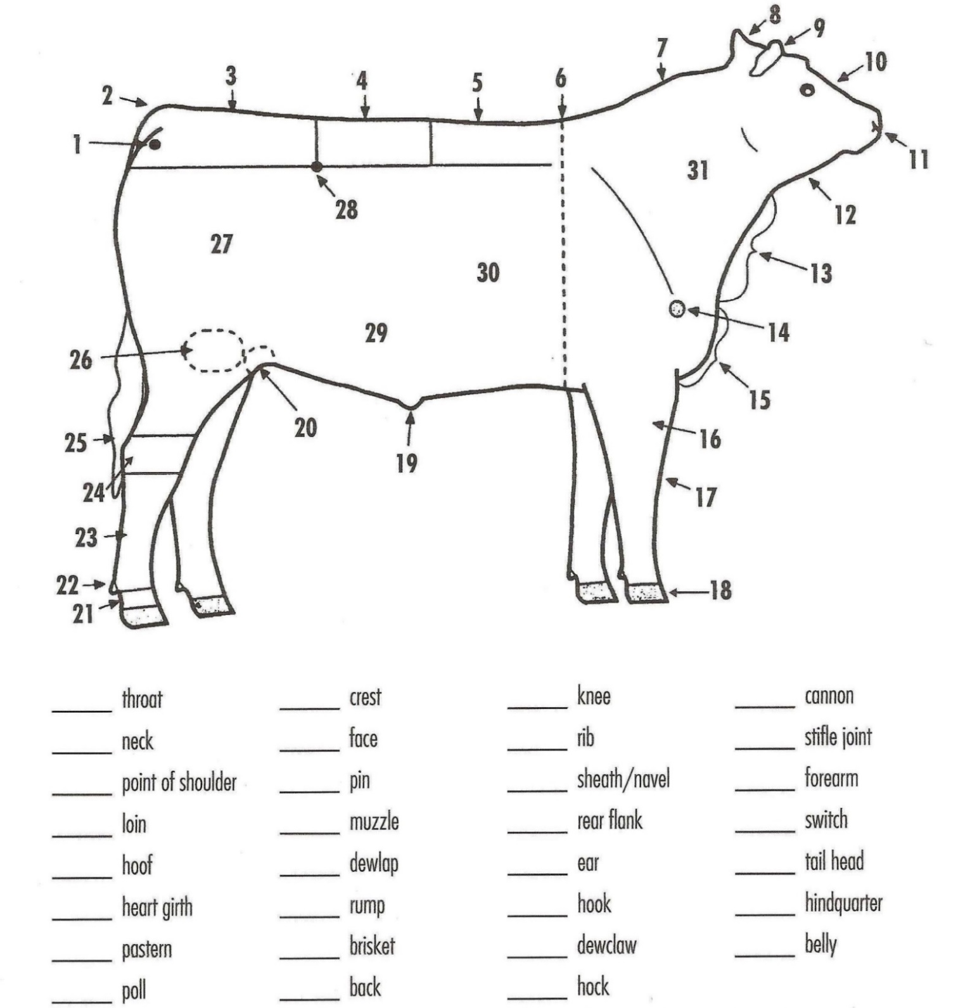

References: Ohio 4-H Beef, Sheep,& Swine Selection and Evaluation Book #103R; Beef Learning Laboratory Kit

Prepared by: Jodi Black, State Extension Association, 4-H/Animal Sciences, and Andrea Auker, Animal Sciences Student

2023- STEER RECORD BOOK (15-19) Page 13

**HALTER BREAKING YOUR PROJECT**

Circle the correct answer for each question:

1. Calves need to be broke to lead:
2. One week before the show
3. One month before the show
4. Several months before the show when they are still calves
5. The first step to halter breaking a calf is:
6. Letting the calf drag a halter for a week before tying it up
7. Tranquilizing the calf
8. Buyer batteries for the electric cattle prod
9. The second step to halter breaking is:
10. Finding someone that weighs more than the calf to drag the calf around
11. Tying the calf up for short periods of time while watching it constantly
12. Trading the cattle prod in for a pitchfork
13. The third step in halter breaking is:
14. Putting on your spurs and riding the calf around the barn yelling YEEEHAAW!
15. Letting your calf run free around the barn and try to at least hold on to the end of the halter
16. Leading your calf to feed and water everyday
17. Calves are trained to lead by using a:
18. Tractor
19. Local body builder
20. Patient, calm person
21. When things go wrong:
22. Take the calf to the sale barn and get another
23. Keep working until things go right
24. Lose your temper and hit things
25. To help a calf get used to strange noises at the fair you should:
26. Play a radio in the barn
27. Yell around them
28. Throw firecrackers under them
29. Calves need to wear halters:
30. Only long enough to break them to lead and then when you are working with them
31. From the time you first catch them to market
32. All day because the calf likes it when the halter grows into their nose
33. Calves need to be tied:
34. The whole time you own them, so they don’t get away
35. All day long because they are easier to catch
36. A few hours a day but only when you are around to watch them

2023- STEER RECORD BOOK (15-19) Page 14

**RETAIL CUTS**- WRITE THE CURRECT CUT ON THE LINE IT MATCHES BELOW

**WORD BANK**

Brisket

Chuck Roast

Flank Steak

Ground Beef

Rib Steak

Round Steak

Rump Roast

Short Ribs

Sirloin Steak

Stew Beef

T-Bone Steak

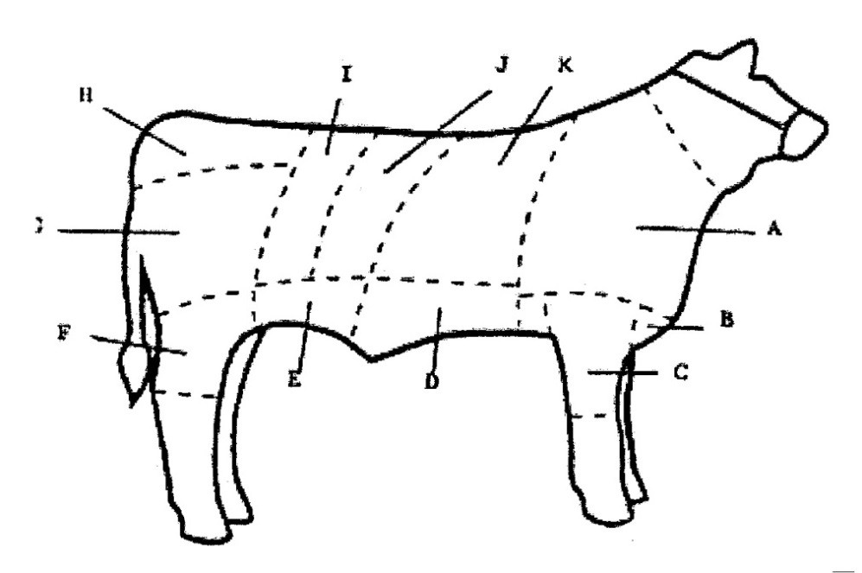

**K**

**J**

**I**

[Grab your reader’s attention with a great quote from the document or use this space to emphasize a key point. To place this text box anywhere on the page, just drag it.]

**H**

A._______________________­­____ G. ______________________

**G**

**F**

**E**

**D**

**C**

**B**

**A**

B.___________________________ H. ________________________

C.___________________________ I. ________________________

D.___________________________ J. ________________________

E.___________________________ K. ________________________

F.___________________________

**WHOLESALE CUTS OF BEEF**

Fill in the name of number that coincides with the correct part.

_____ Brisket

____ Chuck

____ Flank

____ Loin

____ Plate

____ Ribs

____ Round

____ Shank

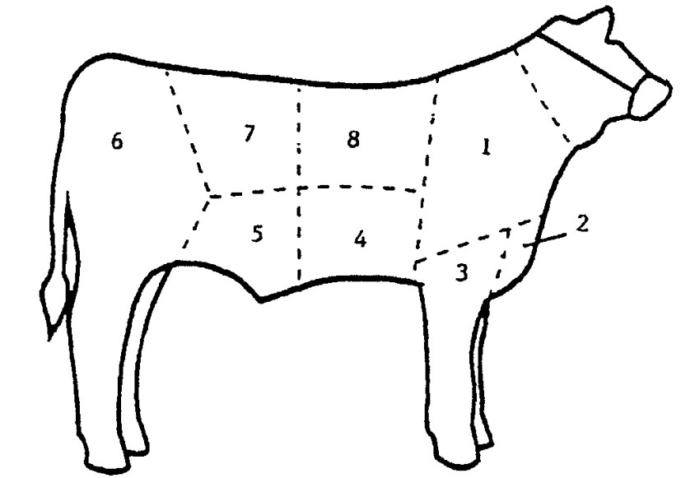

2023-STEER RECORD BOOK (15-19) Page 15

**YOUR PROJECT**

(Please answer to the best of your ability.)

1. What did you learn that you didn’t know about your project? ____________________

_______________________________________________________________________

_______________________________________________________________________

_______________________________________________________________________

2. What are 2 marketable features of your animal that you would share with potential buyers?

_______________________________________________________________________

_______________________________________________________________________

_______________________________________________________________________

3. What feature(s) of your market steer could use improvement? ___________________

______________________________________________________________________

______________________________________________________________________

______________________________________________________________________

4. Will you participate in the market steer project again? __________________________

Why or why not? ______________________________________________________

____________________________________________________________________

_____________________________________________________________________

_____________________________________________________________________

2023-STEER RECORD BOOK (15-19) Page 16

**4-H INFORMATION**

**The 4-H Pledge**

(fill in the blanks)

***I pledge…***

My____________________________________________________________________,

My_____________________________________________________________________,

My_____________________________________________________________________,

and My__________________________________________________________________,

For my____________________________, my __________________________________,

my______________________________, and my ________________________________.

**LIST 1 WAY THAT YOU HELPED OR TAUGHT OTHERS THIS YEAR:**

__________________________________________________________________________

__________________________________________________________________________

__________________________________________________________________________

__________________________________________________________________________

__________________________________________________________________________

**What is one interesting thing that happened with your animal this year?**

__________________________________________________________________________

__________________________________________________________________________

__________________________________________________________________________

__________________________________________________________________________

__________________________________________________________________________

__________________________________________________________________________

**The 4-H Pledge**

(fill in the blanks)

***I pledge…***

**________________________________________________________________,**

**________________________________________________________________,**

**________________________________________________________________,**

**________________________________________________________________,**

**________________________________________________________________,**

**________________________________________________________________.**

**The 4-H MOTTO:**

____________________________________________________________________________

2023-STEER RECORD BOOK (15-19) Page 17

**POTENTIAL BUYER’S NAMES**

As part of your 4-H Market Livestock Project, you must personally contact at least three potential buyers before the Oceana County Fair. You are encouraged to try to seek at least 1 new buyer that have not been asked or submitted before. T**hree different buyers than those of your siblings are required, in the market livestock project**. Please confirm with your buyers their accurate mailing address (example: post office box vs. a street address). The information on page 15 must be completed and taken to the Oceana County MSU Extension Office on or before the due date where it will be **copied** and used to send out letters to your potential buyers. This page will remain in your notebooks. This is a Market Livestock Committee rule. Failure to comply will result in not being able to sell your animal in the 4-H Market Livestock Sale.

2023- Steer Record Book (15-19) Stamp _______________

Page 18 Staff _______________

**4-H MARKET LIVESTOCK POTENTIAL BUYER’S LIST**

**STEER PROJECT (AGES 15-19)**

Name______________________________ Club_________________________

***Please print business names and complete addresses clearly.***

* 1. Contact Name ________________________________________________­­____

Business Name ____________________________________________________

**Mailing** Address _________________________City__­­­­­­­­__­­­­­­­_____________Zip_____

Phone _______________________ After Hours Phone______________________

Mailing Preference (Please Check One): Email ____ Postal Delivery ____

Email ____________________________________________________________

Signature__________________________________________________________

2. Contact Name ________________________________________________­­____

Business Name ____________________________________________________

**Mailing** Address _________________________City__­­­­­­­­__­­­­­­­_____________Zip_____

Phone _______________________ After Hours Phone______________________

Mailing Preference (Please Check One): Email ____ Postal Delivery ____

Email ____________________________________________________________

Signature__________________________________________________________

3. Contact Name ________________________________________________­­____

Business Name ____________________________________________________

**Mailing** Address _________________________City__­­­­­­­­__­­­­­­­_____________Zip_____

Phone _______________________ After Hours Phone______________________

Mailing Preference (Please Check One): Email ____ Postal Delivery ____

Email ____________________________________________________________

Signature__________________________________________________________

(Must be stamped by the MSU Extension Office)

2023- Steer Record Book (15-19) Stamp _______________

Page 19 Staff _______________

**If you would like to contact additional buyers, you can use this page. If not, please throw this page out.**

**Contact Name**  ________________________________________________­­____

Business Name ____________________________________________________

**Mailing** Address _________________________City__­­­­­­­­__­­­­­­­_____________Zip_____

Phone _______________________ After Hours Phone______________________

Mailing Preference (Please Check One): Email ____ Postal Delivery ____

Email ____________________________________________________________

Signature__________________________________________________________

**Contact Name** ________________________________________________­­____

Business Name ____________________________________________________

**Mailing** Address _________________________City__­­­­­­­­__­­­­­­­_____________Zip_____

Phone _______________________ After Hours Phone______________________

Mailing Preference (Please Check One): Email ____ Postal Delivery ____

Email ____________________________________________________________

Signature__________________________________________________________

**Contact Name** ________________________________________________­­____

Business Name ____________________________________________________

**Mailing** Address _________________________City__­­­­­­­­__­­­­­­­_____________Zip_____

Phone _______________________ After Hours Phone______________________

Mailing Preference (Please Check One): Email ____ Postal Delivery ____

Email ____________________________________________________________

Signature__________________________________________________________

2023- STEER RECORD BOOK (15-19) Page 20

**YOUR PROJECT PICTURES**

(Please use this page for your project pictures. If you have more than 1 page of pictures

please use the appendix section to include those pictures. The judges like if you caption your photos so they know what they are viewing)

# NON-CLUB POINTS

**8 YEARS OLD & UP MUST COMPLETE- MARKET LIVESTOCK ANIMAL ASSOCATION PROJECT ATTENDANCE RECORD**

***(This must be filled out before presenting for signatures at the office.)***

|  |  |  |  |  |
| --- | --- | --- | --- | --- |
| **MEETING NAME** | **LOCATION** | **DATE** | **POINTS** | **SIGNATURE OF LEADER, SUPERINTENDENT OR MSU STAFF** |
|  |  |  |  |  |
|  |  |  |  |  |
|  |  |  |  |  |
|  |  |  |  |  |
|  |  |  |  |  |
|  |  |  |  |  |
|  |  |  |  |  |
|  |  |  |  |  |

Please note: This form must be included with your record notebook and turned into the weigh master on entry day of the Fair. **BEFORE SEEKING SIGNATURES AT MSU EXTENSION – MEETING NAME AND DATE MUST BE COMPLETED.**You need to accumulate **nine (9) points** to be allowed to sell your animal. **Six (6)** of these **nine (9) points** must come from club meetings. The **three (3)** non-club points must be earned from attending various 4-H events and activities. See your leader, the MSUE office, or online <https://www.canr.msu.edu/oceana/oceana_county_4_h/oceana_4_h_market_livestock> for a listing of approved nonclub points.

# CLUB POINTS

**MARKET LIVESTOCK ATTENDANCE RECORD- ALL AGES MUST COMPLETE**

|  |  |  |  |  |
| --- | --- | --- | --- | --- |
| **MEETING NAME** | **LOCATION** | **DATE** | **POINTS** | **SIGNATURE OF LEADER, SUPERINTENDENT OR MSU STAFF** |
|  |  |  |  |  |
|  |  |  |  |  |
|  |  |  |  |  |
|  |  |  |  |  |
|  |  |  |  |  |
|  |  |  |  |  |
|  |  |  |  |  |
|  |  |  |  |  |
|  |  |  |  |  |

Please note: This form must be included with your record notebook and turned into the weigh master on entry day of the Fair. You need to accumulate **nine (9) points** to be allowed to sell your animal. **Six (6)** of these **nine (9) points** must come from club meetings. The **three (3)** non-club points must be earned from attending various 4-H events and activities.